Video - https://youtu.be/qyM0gSem1Oc
Notes - https://drive.google.com/file/d/1_NneptkVJU-b6D518RLyUIWxFaJtopSo/view

Measuring the Running time of a program

How can you perform complexity analysis or analysis the running time of a program in machine independent way?

Running time of a Algorithm is defined in term of:

T(n) Where n is either the input number or number of elements in your input

T(n) = c(n²)

- Where c is constant -
- we leave the unints of T(n) unspecified.
- [
The primary reason to leave T(n) unspecified is because we don't want it to be defined in terms of MIPS of the number. That is how many million instruction can it perform. But what we do is we generally refer to these units as operations that can perform on an ideal computer
]

- T(n) - generally refer to as the worst case time complexity.
[
What i mean by worst case running time?
I'm saying maximum over all possible inputs. That's gererally the meaning of T(n)
]

T _{avg} (n) - T average of n - You are looking at the average of all input of size of n.
[What its means is that it gererally T(n) is little bit difficult to compute.]

What is Big-O, Big-Ω notation?

Notation:

T(n) = O(n²) => for constant c and n₀

s.t. n >= n₀ , T(n) <= cn²

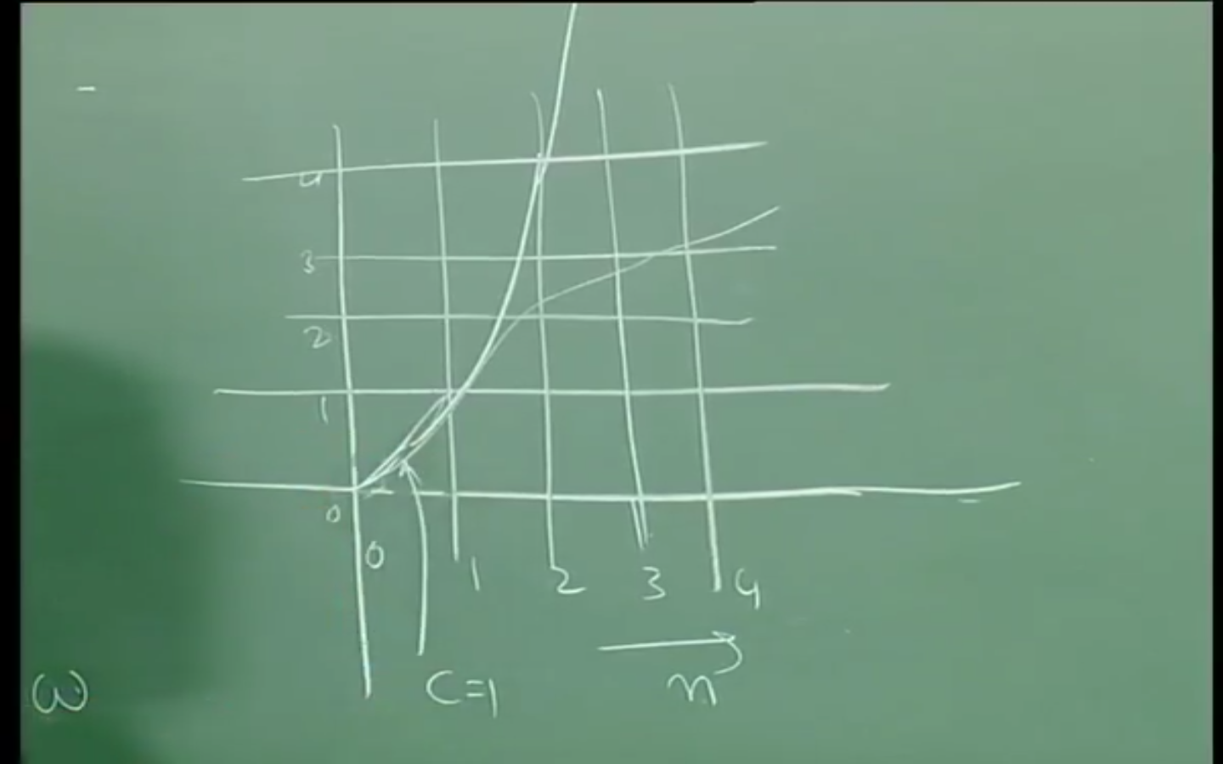
T(n) = O( f(n) ), Then f(n) is upper bound of growth rate.

Example:-

T(n) = n² + 2n -1

T(n) = O(n²) // Upper Bound

c₁n₀

s.t. T(n) <= cn²

T(n) = Ω(g(n)), then g(n) a lower bound on the growth rate.

T(n) = Ω(n²) // Lower Bound

Rules for computing Running time:

- Sum Rule
- Product Rule

Sum Rule:

If P = P₁ + P₂

Where P₁ and P₂ are program segments
If T₁(n) = O(f(n)) and
T₂(n) = O(g(n)), then
T(n) = O( max(f(n), g(n)) )
[
If the compute time for program P₁ is T₁(f(n)) and the compute time for P₂ is T₂(g(n)). Then Its says the running time for entire program P is max(T₁(f(n)), T₂(g(n))
]

Product Rule:

If P = P₁ . P₂

Where P₁ and P₂ are program segments
If T₁(n) = O(f(n)) and
T₂(n) = O(g(n)), then
T(n) = O( f(n)g(n) )

for (i = 0; i < n; i++)
{ __
|
| P₂
|__
}

[ P₂ is executed P₁ times ]

